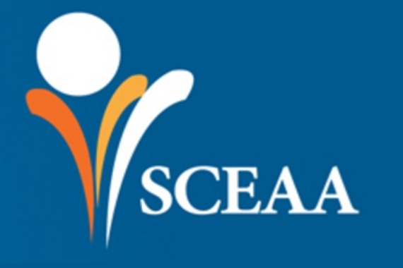

SCEAA Conference 2018

Papers and workshops abstract submission form

Name and title of presenter
School, university or education affiliation
Email address
Phone number
Permission to include email contact in conference presenter list | Yes  No (delete one)
Workshop title and abstract
Note: all workshops are one hour duration

Paper title and abstract
Note: all papers include a 20 minute presentation and 10 minutes questions and discussion

Any other comments or requests:

Email the completed form to peter.brett@utas.edu.au before January 30th 2018.

